Thank you for choosing Prestige Photographic as the official photographer at your graduation ceremony. All graduates are photographed and archived on our computer system to ensure ordering now, or in the future, is a simple process.
We have three main procedure options for you to consider.

- Standard graduation
- Online ordering
- Discounted Package (Print for all option)

STANDARD GRADUATION:
A standard graduation is where graduates will order and pay for stage and family packages directly to the photographer at the event. Only those graduates interested in the packages would be photographed. The institution can choose whether we post the photographs directly to the graduates, or deliver to the campus.

STAGE PACKAGE:
R300
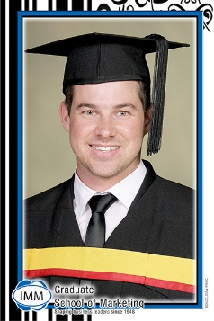
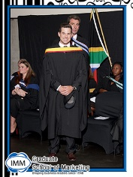
- A4 enlargement
- A5 stage photo
- 2 x Jumbo prints
- Hi-res electronic images
- Postage or delivery to campus

- ONLY digital images R250

INCLUDES
Hi-res electronic image sent by email

R120
FAMILY PACKAGE:
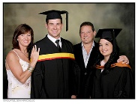
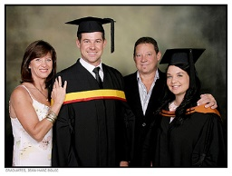
- A5 enlargement
- 2 x Jumbo prints
- Hi-res electronic image
- Postage or delivery to campus

- ONLY digital images R100
INCLUDES
Hi-res electronic image sent by email

ONLINE ORDERING:
Safe and secure online ordering encrypted to allow only approved access. Place and pay for orders online. No cash. No order mistakes. Immediate downloading of electronic images. Client can view all images and choose print sizes as required.

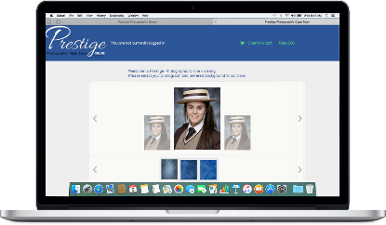

DISCOUNTED PACKAGE (Print for all option):
Packages can be offered at discounted rates by using a print for all option. There is no administration at the event. We simply photograph all the graduates, print the stage package for all, and deliver everything to the campus.
- Stage package with electronic image = R250
- Stage package prints only = R200
- Family Package prints only = R70

Please fill in a form for each photo day booking

Thank you for booking with Prestige Photographic.
Please assist us in keeping our records up to date and include any new details.
Our database system link names to photographs; to do this, we require your graduates lists as well as their email addresses in a digital format.
This data must be e-mailed to the relevant branch. NOTE: FAXED OR SCANNED LISTS ARE UNUSABLE.

Name of institution: Institution: |  |  | Principal:
Contact person: |  |  | Tel:
Cell: |  |  | Fax:
e-mail:
Campus Physical address: |  | Accounts contact:
 |  | Accounts tel:
 |  | Accounts email:
Shoot information and design options
Date of Shoot: |  | Time to start: | Number of individuals:
Number of graduates: |  | Year on prints:
Preferred Method: | Standard Graduation:  Print for all:  Online ordering:  (Both Standard and online ordering requires email addresses of the graduates)
Venue Address:
Special Requests:
Benefits:
Standard Border: South African: Atlantis: Torn Pper: Glass beads: Wood:
TR of
The appearance of our packages can be customized without affecting their content or price. Our production team will gladly make a design that compliments your institution. Please let us know if you have and design requests in mind.
Every institution will receive the following complimentary items as standard:

- Photographs of the guest speaker
- Photographs of award winners
- Staff group photo
- Graduate poster when all graduates are photographed
Booking made by / Date
- CD with formal photographs for administration purposes

Office Use

 | Head Photographer | Account Manager | Invoice Number
 | Photographers

